**VALUE ADDITION ON VEGETABLES**

**Reasons for preserving vegetables rather than selling them fresh.**

* Extends shelf life allowing them to be stored for long
* Ensures availability throughout the year since preserving allows vegetables to be available beyond the natural seasons
* It adds value to vegetables allowing them to be used for several purposes
* Saves costs that would have been used to buy vegetables when they are in scarcity
* Offers food security during emergencies
* Reduces food wastage
* Convenient to use as they are readily available for use without need for frequent shopping
* Certain preservation methods such as freezing retains nutritional value of vegetables

**How to find information on vegetable processing**

* Online search
* Research papers and journals
* Government and industrial websites
* Books and publications
* Professional organizations
* Consult experts
* Online courses

**Methods of processing vegetables**

* Drying Blanching
* Dehydrating Canning
* Freezing Fermenting
* Pickling

**CANNING**

This involves preserving vegetables in air tight containers such as glass jars and by using heat to destroy microorganisms

**Procedure**

* Gather materials to use such as canning jars, boiling water, fresh vegetables. e.t.c
* Prepare the jars and equipment by washing and sterilizing them. Keep jars hot until ready to use
* Prepare vegetables by washing them, peeling and chopping into suitable pieces
* Blanch the vegetables by briefly immersing them in water to stop enzyme activity
* Pack blanched vegetables into hot sterilized jars
* Gently press down the vegetables on the sides of jars to remove air bubbles
* Seal the jars
* Put jars in a large pot and add water to the pot
* Boil water for a recommended time
* Cool the jars
* Store cooled jars in a cool dark place

**DRYING VEGETABLES**

**PROCEDURE**

* Choose fresh vegetables free from bruises
* Wash the vegetables with clean running water
* Peel and slice vegetables in uniform pieces
* Place prepared vegetables on drying trays under direct sunlight
* Cover vegetables with mesh or cheesecloth to protect them from insects
* Turn vegetables to ensure uniform drying
* Once dried, allow vegetables to cool to room temperatures
* Place vegetables in air tight containers
* Store dried vegetables in a cool dry dark place
* When using dried vegetables, rehydrate by soaking in water to make them tender

**Methods of drying vegetables**

* Solar drying
* Oven drying
* Air drying

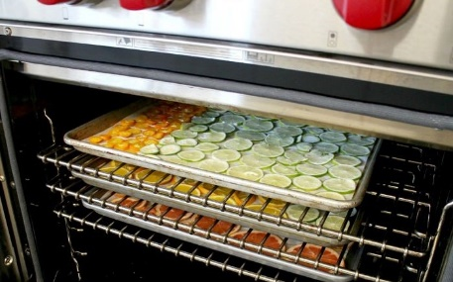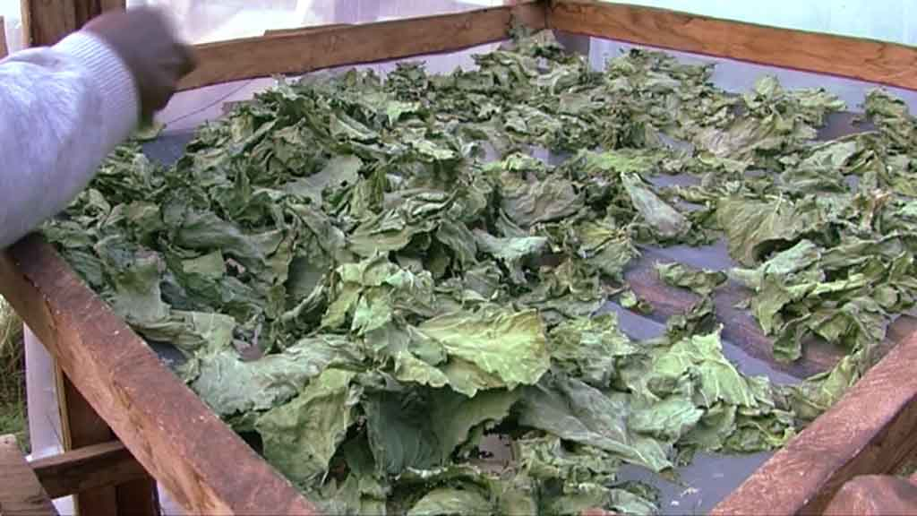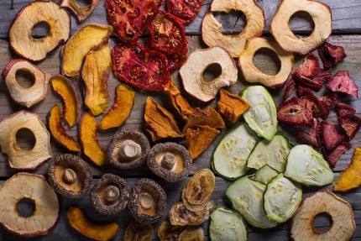

**Principles of drying vegetables**

* Moisture removal to reduce microbial growth
* Preservation of nutrients
* Texture retention
* Color retention
* Uniform drying to ensure quality
* Safe storage to maintain quality

**FREEZING VEGETABLES**

* It involves blanching vegetables briefly in hot water to deactivate enzymes
* The vegetables are then rapidly cooled and frozen
* Frozen vegetables retain their nutritional value, texture and color

**PICKLING**

* This involves preserving vegetables in a vinegar solution, salt and spices
* It creates an acidic environment that prohibits growth of bacteria and adds flavor
* Pickled vegetables can be stored for an extended period in sealed jars

**BLANCHING**

* Is a preprocessing step used before freezing or canning
* It involves briefly immersing vegetables in boiling water or steam to stop enzyme activity and remove surface dirt. It maintains color, texture and nutritional quality during storage

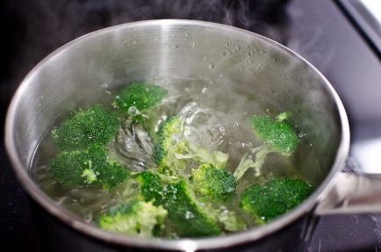

**FERMENTATION**

* It’s a natural preservation method which involves conversion of sugars in vegetables into acids by beneficial microorganisms
* Fermented vegetables have an extended shelf life

**DEHYDRATING**

* Fresh vegetables are blanched and placed in a dehydrator or oven to dry
* They are then cooled and stored in air tight containers in a cool dark dry place
* They are then rehydrated when in use

**Preserving vegetables using acids**

Preserving vegetables using acids is known as pickling

**Procedure for pickling**

* Select fresh vegetables
* Wash vegetables thoroughly in clean running water
* Trim, peel vegetables if necessary
* Prepare the pickling liquid by combining vinegar, water, salt and sugar in the desired proportions
* Heat the pickling liquid to boil over medium heat, stir to dissolve the salt and sugar completely
* Allow the liquid to simmer for a few minutes
* Pack vegetables in clean sterilized jars
* Pour pickling liquid over the vegetables and the liquid should cover the vegetables completely
* Press the vegetables by using a bubble removal to remove air bubbles
* Seal the jars by covering the jars with sterilized lids
* Store the jars in a fridge

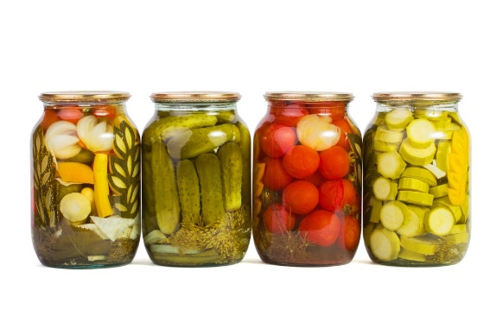

**Preserving vegetables using sugar**

This method is known as candying or sweet pickling

**Procedure**

* Choose fresh vegetables
* Wash vegetables with clean water
* Peel and cut into suitable pieces
* Prepare the sugar syrup by mixing water and sugar in the required ratio
* Boil the sugar syrup over medium heat
* Add the prepared vegetables to the boiling syrup and reduce the heat to simmer
* Cook the vegetables in the syrup until they are tender but still retain their shape
* Once cooked to the desired tenderness, then remove vegetables from syrup using a spoon
* Let the vegetables cool to room temperature
* Put the vegetables in sterilized jars
* Store the vegetables along with some sugar syrup in air tight containers under a cool dark place
* Use vegetables

**Preserving vegetables using salt**

This method is known as salting or brining

**Procedure**

* Select fresh vegetables
* Wash vegetables in clean running water
* Peel and chop vegetables in suitable shapes
* Prepare salt solution (brine) by dissolving salt in water
* Place the prepared vegetables in the brine solution ensuring they are fully submerged
* Cover the containers with a clean lid but do not seal it completely
* Allow the vegetables to ferment at room temperature for several days but it’s optional
* Once fermentation is over, transfer vegetables from brine to sterilized jars
* Seal the jars tightly
* Store vegetables in a refrigerator
* Use vegetables

**PRINCIPLES OF PRESERVING VEGETABLES**

* Removing microorganisms through reducing moisture and lowering temperature
* Inactivating enzyme through blanching
* Removal of insects
* Adding chemicals like acids to inhibit enzymatic reactions and microbial growth
* Adding salt to dehydrate food
* Fermenting vegetables to prolong shelf life
* Control of temperature
* Manage ph. Value
* Reduce oxygen exposure since it can lead to oxidation of vegetables
* Maintain hygiene
* Monitor storage conditions

**MARKETING PROCESSED VEGETABLES**

* Choose a suitable processing method to use in order to develop a processed product
* Ensure good quality products
* Know consumer demands
* Establish market research
* Ensure proper packaging
* Ensure proper branding
* Create distribution channels e.g. supermarket
* Ensure effective transportation
* Establish partnerships with distributers
* Create promotion and awareness of the product
* Educate consumers about benefits of processed vegetables
* Set fair prices
* Get and analyze consumer feed back